

Up and Atom:   
An App to Help You With Your Morning Routine!

**CSC 7054  
Web and Mobile App Development**



Team Members:

Hannah Butler (40004276)  
Kelvin Harron (40042864) (Group Leader)  
 Peter McCaughey (14531046)  
 Conor Taggart (40164315)

Introduction

For this project, we decided to create an Android App using Android Studio. After discussing a number of options, we decided to develop an App that would set off an alarm when the user requested – however, to help those that aren’t “morning people”, the user would have to scan a preassigned Barcode to get the alarm to stop. The idea behind this would be that the user would leave the Barcode to be scanned out of reach, therefore motivating them to get out of bed to make the alarm stop, thus helping along with their morning routine. While there are a few alarms with this feature available on the marketplace, we felt that our twist – geotagging – would make it a more interesting product.

Requirements  
Problem Statement

The original problem faced by the potential customer is that many alarms are easily dismissed; people often do this in their sleep without realising and can often sleep through alarms meaning they are late for work, flights or important social engagements. The Play Store is heavily inundated with various alarms that request for a maths problem to be solved, a general knowledge question to be answered or a pattern to be drawn and while these engage with the brain, few actually get the user up and out of bed. While developing this idea we thought that it could develop it into a “Morning Routine” App – attach Barcodes to essential daily belongings also (wallet, keys) so that the user has to scan these items before they leave the house otherwise an alarm goes off and won’t stop until the correct Barcode is scanned.

System Requirements

A requirement is defined as “a condition or capability to which a system must conform”. A number of requirements for the App were extracted from the Problem Statement and are listed below;

|  |  |  |  |
| --- | --- | --- | --- |
| **No.** | **Requirement** | **Brief Description** | **Priority Weight** |
| 1. | User is able to view alarms | User is able to view and select different alarms that are already set. If there are no alarms, then a home screen is presented |  |
| 2. | User is able to set an alarm time | User is able to select any time within a 24 hour cycle, on any day of the week |  |
| 3. | User is able to set a home location | User is able to select a location as their “home” so the alarm won’t request a Barcode if they are outside of this location |  |
| 4. | User is able to pre-set Barcode | User is able to pre-set any Barcode to be scanned to deactivate alarm once activity is triggered |  |

|  |  |  |  |
| --- | --- | --- | --- |
| 5. | User is able to snooze alarm | User is able to snooze the alarm for a pre-set amount of time rather than scan the Barcode |  |
| 6. | User is able to override Barcode | User is able to enter an override code rather than scan the Barcode if they are outside their home location |  |
| 7. | App is easy to navigate | Usability is essential in this App; the process must be made clear to the user |  |
| 8. | App is clean and modern looking | A modern looking UI is essential to fit in with the Bootstrap aesthetic users are used to |  |

Functional Requirements Specification

1. Actors and Goals

As the App will be available to the members of the general public they will be the main actors who will interact with this App. The goal of the user using the app will be to improve their morning routine. This is covered in the System Requirements which will be included in the finished product.

1. Use Cases

// TO DO

|  |  |  |
| --- | --- | --- |
| **No.** | **Casual Description** | **Related Requirement(s)** |
| 1 | User can view alarms | 1 |
| 2 | User can add, edit and delete an alarm | 2, 3, 4 |

Use Case Diagram  
Appendix A

User Interface Specification:  
a) Design

After deciding on the premise of the App, the initial design was mocked up on Sketch for Mac. with ideas on how the main screens of the App would appear, what functions we would like that vary from other alarm Apps on the market, and ensuring it was intuitive and aesthetically pleasing to a user. The initial mockups are shown below:

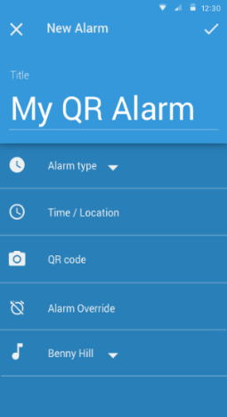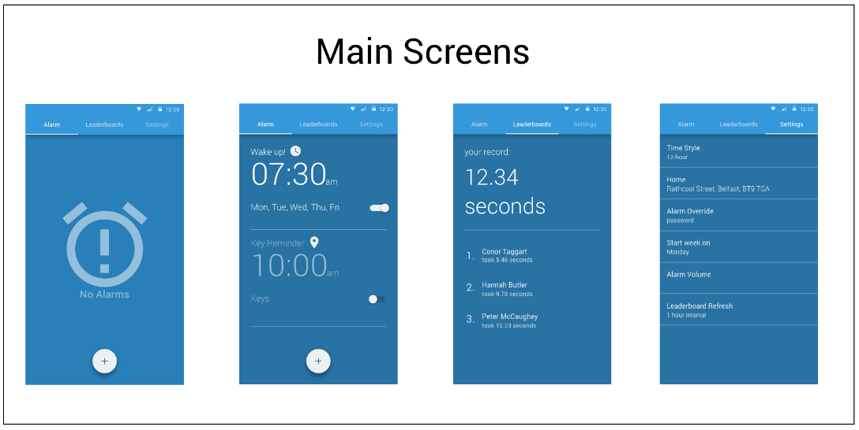

*Fig. 1*

*Fig. 5*

*Fig. 4*

*Fig. 3*

*Fig. 2*

Initially, an extra feature we thought could be included with the app would be a leaderboard (Fig. 4) so that users could connect with friends and compete on weekly leaderboard, similar to apps such as MyFitnessPal or FitBit. This would be feature we would hope to further develop as the App userbase grew.

Design  
a) Features

b) Database

A database was created to hold the alarm preferences, the Barcode string, and the user override code. This can be seen below:

c) Barcode scanner

The Barcode was implemented by using the ZXing (Zebra Crossing) github library. This was interesting to implement because the library often requires you to install an external app alongside to use the results within your App. However, because we were only interested in receiving and analysing data from a Barcode, we were able to minimise the amount of the library required, and have it run as a gradle.build as opposed to importing all the libraries of the ZXing app.

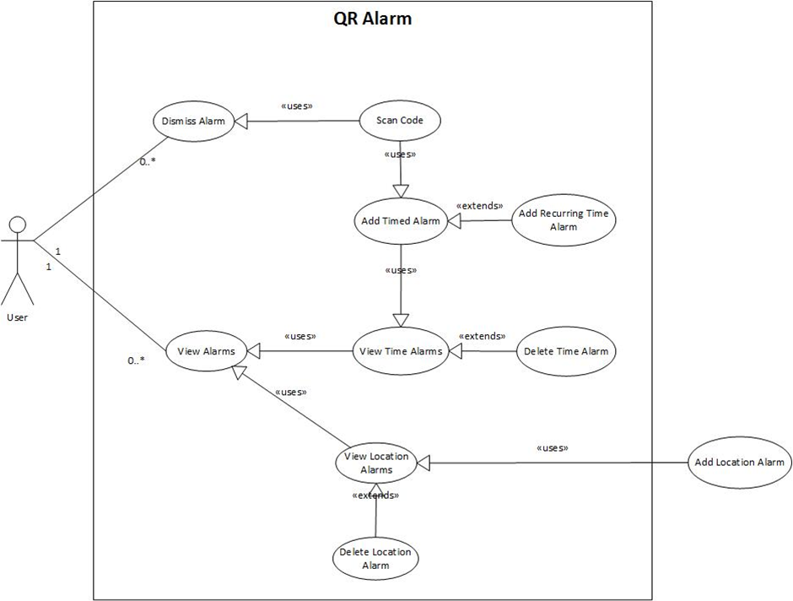

**Appendix A**

**Appendix B**Gantt Chart

|  |  |  |  |  |  |
| --- | --- | --- | --- | --- | --- |
|  | Week 1 | Week 2 | Week 3 | Week 4 | Week 5 |
| **Project Deliverables** |  |  |  |  |  |
| Main Activity and XML |  |  |  |  |  |
| Alarm Screen Activity and XML |  |  |  |  |  |
| Setting Screen Activity and XML |  |  |  |  |  |
| Java code for Alarm Screen and Setting |  |  |  |  |  |
| Location Screen Activity and XML |  |  |  |  |  |
| SQL Lite Database |  |  |  |  |  |
| Geomaps Fragment and XML |  |  |  |  |  |
| Barcode Library and Implementation |  |  |  |  |  |
| Java code for Alarm Class, Broadcaster and Receiver, and Dialog Fragment |  |  |  |  |  |